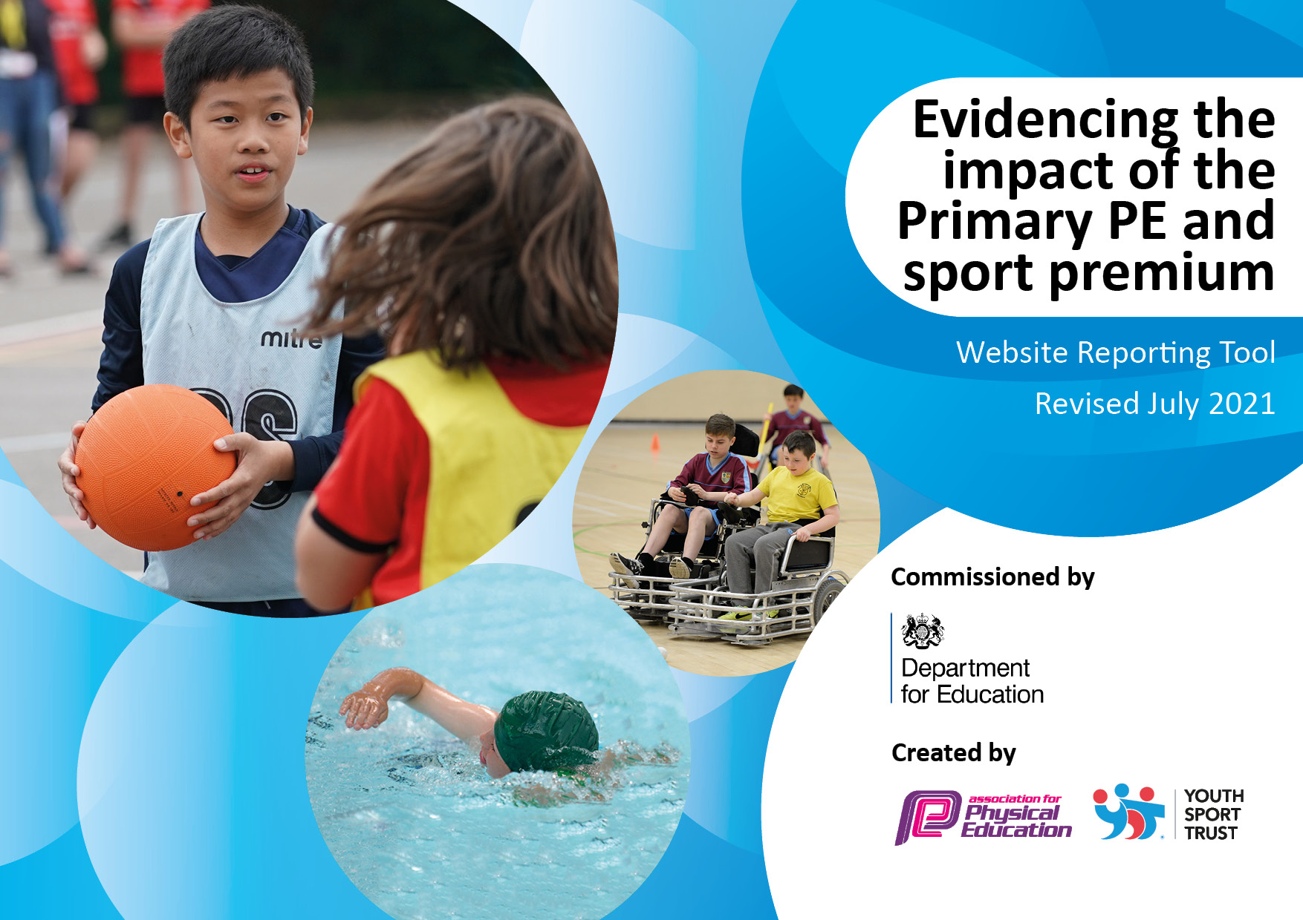
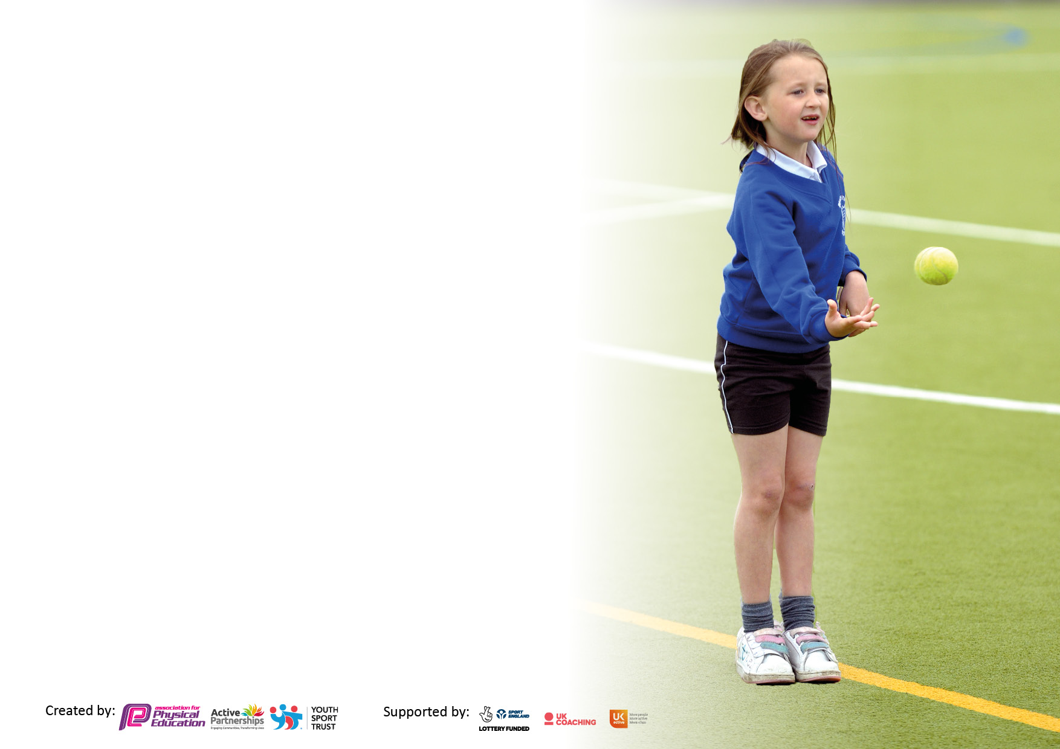

It is important that your grant is used effectively and based on school need. The Education Inspection Framework makes clear there will be a focus on ‘whether leaders and those responsible for governors all understand their respective roles and perform these in a way that enhances the effectiveness of the school’.

Under the Quality of Education Ofsted inspectors consider:
Intent - Curriculum design, coverage and appropriateness
Implementation - Curriculum delivery, Teaching (pedagogy) and Assessment
Impact - Attainment and progress

To assist schools with common transferable language this template has been developed to utilise the same three headings which should make your plans easily transferable between working documents.

Schools must use the funding to make additional and sustainable improvements to the quality of Physical Education, School Sport and Physical Activity (PESSPA) they offer. This means that you should use the Primary PE and sport premium to:

- Develop or add to the PESSPA activities that your school already offer
- Build capacity and capability within the school to ensure that improvements made now will benefit pupils joining the school in future years
- The Primary PE and sport premium should not be used to fund capital spend projects; the school’s budget should fund these.

Pleasevisitgov.ukfortherevisedDfEguidanceincludingthe5keyindicatorsacrosswhichschoolsshoulddemonstrate animprovement.Thisdocumentwillhelpyoutoreviewyourprovisionandtoreportyourspend.DfEencouragesschools to use this template as an effective way of meeting the reporting requirements of the Primary PE and sport premium.

We recommend you start by reflecting on the impact of current provision and reviewing the previous spend.

Schools are required to publish details of how they spend this funding, including any under-spend from 2019/2020, as well as on the impact it has on pupils’ PE and sport participation and attainment. All funding must be spent by 31st July 2022.

We recommend regularly updating the table and publishing it on your website throughout the year. This evidences your ongoing self-evaluation of how you are using the funding to secure maximum, sustainable impact. Final copy must be posted on your website by the end of the academic year and no later than the 31st July 2021. To see an example of how to complete the table please click HERE.

Details with regard to funding
Please complete the table below.

Total amount carried over from 2019/20 | £0
Total amount allocated for 2020/21 | £20800
How much (if any) do you intend to carry over from this total fund into 2021/22? | £7000
Total amount allocated for 2021/22 | £27800
Total amount of funding for 2021/22. To be spent and reported on by 31st July 2022. | £27800
Swimming Data
Please report on your Swimming Data below.

Meeting national curriculum requirements for swimming and water safety.

N.B. Complete this section to your best ability. For example you might have practised safe self-rescue techniques on dry land which you can then transfer to the pool when school swimming restarts.
Due to exceptional circumstances priority should be given to ensuring that pupils can perform safe self rescue even if they do not fully meet the first two requirements of the NC programme of study
What percentage of your current Year 6 cohort swim competently, confidently and proficiently over a distance of at least 25 metres?  N.B. Even though your pupils may swim in another year please report on their attainment on leaving primary school at the end of the summer term 2020.  Please see note above | %
What percentage of your current Year 6 cohort use a range of strokes effectively [for example, front crawl, backstroke and breaststroke]?  Please see note above | %
What percentage of your current Year 6 cohort perform safe self-rescue in different water-based situations? | %
Schools can choose to use the Primary PE and sport premium to provide additional provision for swimming but this must be for activity over and above the national curriculum requirements. Have you used it in this way? | Intended to but due to Covid could not.

Action Plan and Budget Tracking
Capture your intended annual spend against the 5 key indicators. Clarify the success criteria and evidence of impact that you intend to measure to evaluate for pupils today and for the future.

Academic Year: 2020/21 | Total fund allocated: | Date Updated:
Key indicator 1: The engagement of all pupils in regular physical activity – Chief Medical Officers guidelines recommend that primary school pupils undertake at least 30 minutes of physical activity a day in school |  |  |  | Percentage of total allocation:
Intent | Implementation |  | Impact
Your school focus should be clear what you want the pupils to know and be able to do and about  what they need to learn and to  consolidate through practice: | Make sure your actions to achieve are linked to your intentions: | Funding allocated: | Evidence of impact: what do pupils now know and what can they now do? What has changed?: | Sustainability and suggested next steps:
1.The hiring of professional coach to offer extra on top of curriculum provision.  2.Subsidize PE kit and sports equipment | 1.Funding to allow 5 children who do not engage in sport from each year group to take part in after school clubs. Coach to take lunch time activities. Teachers working with Coach to develop confidence in teaching. Coach to take children to after school competitions. Qualified Gym teacher to help implement effect gym lessons.  2.PE kit no longer at school so will need to be ordered from website for children who do not have PE kits. Allows all to take place and use the correct kit. | £4000  £1000 | 1.  20 PP children each half term have benefited from attending a club they would not have been able to attend. Lunch time clubs lead by Professional coach has improved behaviour at lunch time. Gym curriculum has started to be developed, this will be continued next year. Due to no physical competitions taking place we have not been able to use the coach in this way.  2.Kits provided to children, Children able to be involved in PE lessons effectively. Not all money spent in this area. | 1.Communication between Sports Coaches & Teaching Staff is important to ensure that teachers do not become de-skilled & so that there is accurate assessment, recording & reporting.  2.Reduce money spent on this area. Encourage pupils provided with free PE kit to look after & value it. Pass on second-hand to others when it is grown out of.
Key indicator 2: The profile of PESSPA being raised across the school as a tool for whole school improvement |  |  |  | Percentage of total allocation:
Intent | Implementation |  | Impact
Your school focus should be clear what you want the pupils to know and be able to do and about  what they need to learn and to  consolidate through practice: | Make sure your actions to achieve are linked to your intentions: | Funding allocated: | Evidence of impact: what do pupils now know and what can they now do? What has changed?: | Sustainability and suggested next steps:
A clearer pupil voice regarding the teaching of sport. | As part of our service agreement. We will have Madeleine Campbell continue to work with our Sports Leader to develop our Sports council and Change for Life ambassadors. We will look at ways on how to achieve this virtually. We will also need to have a teacher run this club when set up, money available for cover. | £1000 | This has been more challenging due to Covid. We have managed to have Fun Days for each year group and children have given feedback on how to improve. Feedback also given on lunchtime activities. | Pupil Voice & initiative related to PE & Sport becomes the norm. Pupil survey to be conducted to see children’s view on PE.

Key indicator 3: Increased confidence, knowledge and skills of all staff in teaching PE and sport |  |  |  | Percentage of total allocation:
Intent | Implementation |  | Impact
Your school focus should be clear | Make sure your actions to | Funding | Evidence of impact: what do | Sustainability and suggested
what you want the pupils to know | achieve are linked to your | allocated: | pupils now know and what | next steps:
and be able to do and about | intentions: |  | can they now do? What has
what they need to learn and to |  |  | changed?:
consolidate through practice:
Pay for cover to enable staff to undertake CPD opportunities. | High quality and motivating gymnastic lessons catering for all abilities. Opportunity for staff to provide training in other sports to allow us to compete in a wide range of sporting competition. This will allow cover for teachers to observe gym lessons. | £1500 | Gymnastic curriculum beginning to be developed to improve outcome for children. Staff confidence in taking lessons improving but still a way to go in this area. | Next year in a hopefully less impacted year for Covid will allow Staff gain confidence & skills to deliver own PE lessons or extra-curricular clubs. Lesson observations will identify if further training is needed.
Key indicator 4: Broader experience of a range of sports and activities offered to all pupils |  |  |  | Percentage of total allocation:
Intent | Implementation |  | Impact
Your school focus should be clear | Make sure your actions to | Funding | Evidence of impact: what do | Sustainability and suggested
what you want the pupils to know | achieve are linked to your | allocated: | pupils now know and what | next steps:
and be able to do and about | intentions: |  | can they now do? What has
what they need to learn and to |  |  | changed?:
consolidate through practice:
1.Provide a range of sports to all pupils.  2.End of year activity week | 1.Purchase new sports equipment.  Look at PE equipment across the school.  2.Due to Covid, children have not had many experiences or trips. Money would be allocated to each year group to be able offer trips or visitors to come in.  £4800 equates to £10 per child across the school or £1200 per year group.  Money would used to take children on trips to local areas, paying for minibus or coach hire. Allowing sports coaches to come in and take sport sessions during our activity week. We will also use this morning to pay for any equipment needed to engage in these activities. | £2000  £4800 | 1.A wide range of equipment has been purchased. Including athletic equipment which broadens what the children learn and also helps them prepare for competitions.  2. Money not spent on this due to two year groups having to isolate. | 1.Use of pupil survey to help identify sports they would like to try. Sports equipment condition monitored and looked after.  2. Look at doing this next year and seeing how effective it is.

Key indicator 5: Increased participation in competitive sport |  |  |  | Percentage of total allocation:
 |  |  |  | 23%
Intent | Implementation |  | Impact
Your school focus should be clear | Make sure your actions to | Funding | Evidence of impact: what do | Sustainability and suggested
what you want the pupils to know | achieve are linked to your | allocated: | pupils now know and what | next steps:
and be able to do and about | intentions: |  | can they now do? What has
what they need to learn and to |  |  | changed?:
consolidate through practice:
1.Allowing more children to participate in competition.  2.Continue to compete in a range of sports as a school.  3.Extra swimming provision | Contribute towards running costs of 3 minibuses to allow transport to and from a wider variety of competitions and activities.  We have signed up to Silver Level agreement with Portsmouth School Sports Partnership Sport Services.  Offer swimming lessons to those that have missed out due to Covid. | £2000  £2500.  £2000 | 1.We engaged in virtual competition but no physical competition. Even though we did not have any competition, Mini buses still needed to be insured and maintained.  2.Sports partnership offered CPD, virtual competitions and guidance on how to develop a curriculum post Covid.  3.We were unable to do this due to Covid. Money to roll over. | Ensure sufficient staff are trained & qualified to drive minibuses.  Monitor participation in PE & Sports. Try to involving as many children in competitive sport throughout their time at Northern Parade  Keep track of who has swimming lessons in the school and offer extra sessions for those year groups.

Signed off by
Head Teacher:
Date:
Subject Leader:
Date:
Governor:
Date:

