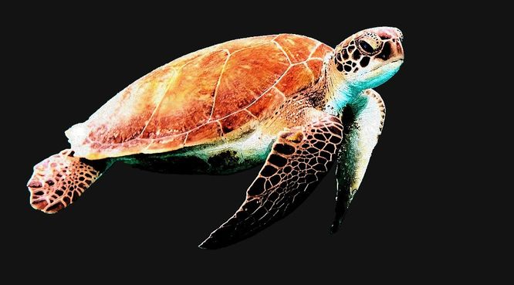
Where’s Wally:
the journey of the wayward sea turtle
Homework: Sea Turtles

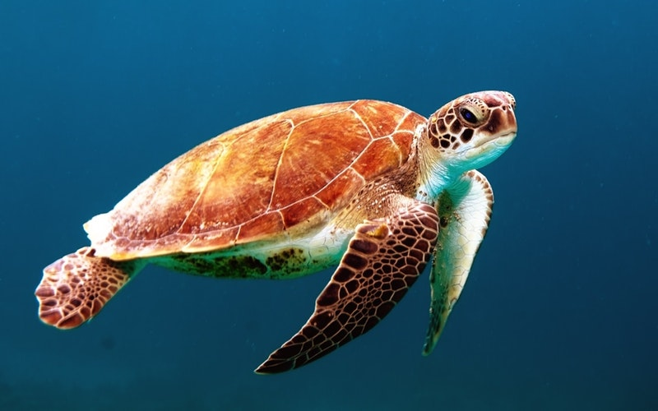

Choose one or two of the following tasks to complete over the next few weeks:

- Create a quiz about a sea turtle after researching the amazing creatures.
- Write a diary entry as though you are a sea turtle. What type of adventures would you have?
- Draw a map to show the location of sea turtles around the world or show on a printed world map.
- Paint, draw or make a model of a sea turtle.
- Create a maths based game about sea turtles (e.g. top trumps or snakes and ladders type games).

Our Values
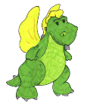Challenge Charlie will help us take risks and have high expectations.
The Teamwork Trio will help us encourage each other and communicate well.
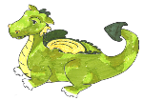Independent Isaac will help us apply our problem solving skills.

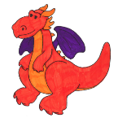Resilient Ruby will help us to keep going with new tasks.

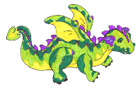 Creative Cristoph will help us use our imagination and ideas in our learning.

Autumn 1

