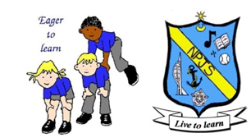
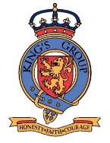
Geography Curriculum Statement

Intent
In line with the 2014 National Curriculum for Geography, our aim is to provide a high-quality Geography education which equips children with locational knowledge, place knowledge, human and physical geography, geographical skills and provides them with experience of fieldwork. The curriculum will provide children with key knowledge about the world around them and the key features of their local area. By the time they leave Northern Parade School, children will have gained key knowledge and skills in the four main areas of Geography. The objectives within each strand support the development of learning across the key stages, ensuring a solid grounding for future learning and beyond.

Implementation
At Northern Parade Schools, Geography is taught using an integrated curriculum approach, allowing the children to progress in their skills and develop their interest and understanding, linked with their current Topic for learning. Teachers use the overview of the current topic to inform them as to where and when Geography learning will take place; the objectives covered are taken directly from the National Curriculum. Teachers are encouraged to link Geography learning across the wider curriculum, as employing cross-curricular links motivates pupils and supports them to make connections and remember the steps they have been taught.
The implementation of the curriculum aims to ensure a balanced coverage of the key areas of Geographical understanding and fieldwork. The children will have experiences of all four strands in each year group, but the subject knowledge imparted becomes increasingly specific and in depth, with more complex skills being taught, making sure that learning is being built upon. For example, children in Key Stage 1 learn to use first hand observations to enhance local awareness, which they will then build upon in Key Stage 2 when they learn to use fieldwork to observe, measure, record and present the human and physical features in the local area using a range of methods, including sketch maps, plans, graphs, and digital technologies.

Impact
Our approach to the curriculum results in a fun, engaging and high-quality Geography education. We aim to showcase the quality of children’s learning through work being completed in Topic books, where it is blended with Topic specific learning in other subjects, such as History and Art. We are also going to aim to develop the use of blocked learning, with teachers leading blocks of discrete Geography lessons to ensure ample coverage and progression of all areas of the Geography curriculum. This supports varied paces of learning and ensures all pupils make good, sound progress.

Review
When:
By whom:
Agreed:

TEAMWORK RESILIENT INDEPENDENT CHALLENGE CREATIVE
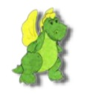
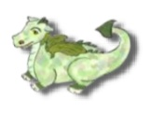
TRIO RUBY ISAAC CHARLIE CHRISTOPH

