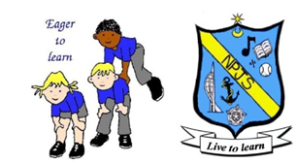
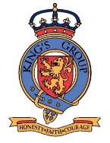
Art Curriculum Statement

Intent

As a school, we believe that art is a vital and integral part of children’s education. It provides them with opportunities to develop a range of ways in which they can share and express their individual creativity, whilst learning about and making links with a wide spectrum of different types of art in our society. Art contributes to children’s personal development in creativity, independence, resilience and self-reflection, which therefore links strongly to our school values. The focus is in developing proficiency in drawing, painting, understanding colour and shade and sculpture, with the overall aim of developing a rigorous understanding, critical awareness and inspiration of art and design.
The art curriculum will develop children’s critical abilities and understanding of their own and others’ cultural heritages through studying a range of artists and designers throughout history.
Children will develop their understanding of the visual language of art with effective teaching and carefully thought out sequences of lessons and experiences. Understanding of the visual elements of art and design (line, tone, texture, colour, pattern, shape, 3D form) will be developed by providing an accessible and engaging curriculum which will enable children to reach their full potential.

Implementation

We teach a skills-based art curriculum, which allows children to express their creative imagination as well as providing them with opportunities to practise and develop mastery in the key processes of art: drawing, painting, printing, textiles and sculpture. This is supported through the studying of key artists and the development of a knowledge of their work.
At Northern Parade schools, the children are taught Art as part of their termly topic work and this can involve studying existing pieces of art and exploring new skills and media before being given the opportunity to use these skills within the context of their topic work. Progressively through the school, the children will then be given experience in evaluating their own work as well as the work of others, and where appropriate be given constructive feedback and next steps, with further opportunities to create the art piece, to improve their work and ensure that the skills are being developed. The evidence of their work is collected within the art sketchbook, which follows the children through the school. Photographs of larger, group or 3D pieces are also kept within this book.

Impact

Children are exposed to a wide variety of skills and knowledge which can influence their own creative style and give them confidence to express themselves through Art. This is shown in their sketch books which are an ongoing record of their progression in Art. Teachers use this information to inform future lessons, ensuring children are supported and challenged appropriately.
Children that lack confidence in other areas of the curriculum can find their voice in Art, raising their self esteem.

Review
When:
By whom:
Agreed:

TEAMWORK RESILIENT INDEPENDENT CHALLENGE CREATIVE
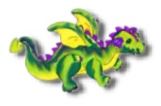
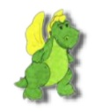
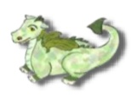
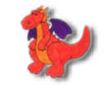
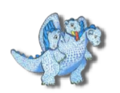
TRIO RUBY ISAAC CHARLIE CHRISTOPH

