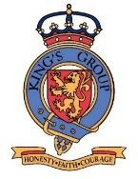
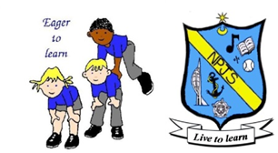
Science Curriculum Statement

Intent
In line with the 2014 Primary National Curriculum in England: science programmes of study, and the 2017 Statutory framework for the Early Years Foundation Stage, our aim is to provide a high-quality Science education which lays the foundations for understanding the world through the specific disciplines of biology, chemistry and physics. The curriculum will build up a body of key foundational knowledge and concepts. Learners will be encouraged to recognise the power of rational explanation and develop a sense of excitement and curiosity about natural phenomena. They will be encouraged to understand how science can be used to explain what is occurring, predict how things will behave, and analyse causes.
By the time they leave Northern Parade School, children will be experienced in ‘working scientifically’ and have gained key knowledge and skills in the three areas of the Science curriculum: Biology (Plants, Animals, including humans, Living things and their habitats and Evolution and inheritance), Chemistry (Materials, States of matter, Seasonal changes, Rocks and Earth geology) and Physics (Light, Forces and magnets, Sound, Electricity and Space). The objectives within each strand support the development of learning across the key stages, ensuring a solid grounding for future learning and beyond.

Implementation
At Northern Parade Schools, Science is taught in two ways: each year, the class teacher incorporates specific elements of the science curriculum into topic lessons, in addition, each class has a one-hour science lesson per week by a specialist facilitator. This ensures children are able to develop depth in their knowledge and skills, whilst being exposed to a broad and varied science curriculum. We recognise however, that it is vital for our pupils to clearly and explicitly understand knowledge and skills that are specific to the subject of science within a broader topic context and that science is a discipline in its own right.
Teachers use their scientific subject knowledge, for the planning of science within their topic lessons, which they supplement with online research. Those planning the discrete science lessons, utilise the ‘Developing Experts’ scheme of work as a starting point and adapt their lessons accordingly. All are encouraged to link these blocks to topics where possible, demonstrating how science is used across numerous areas.
We have a range of science resources, and regularly use the 30 iPads available to each year group and the innovation suite to support learning further. Employing cross-curricular links motivates pupils and supports them to make connections and apply their knowledge in a range of contexts. Applying basic skills of English and maths in science e.g. charts and graphs, writing explanations, provides an important context to reinforce skills from these core subjects.
The implementation of the curriculum also ensures a balanced coverage of science, experiencing all five types of enquiry: observation over time, identifying and classifying, pattern seeking, research and comparative and fair testing, in each year group. Mixed ability groups, visual displays, step-by-step guides, modified work (including pictorial, enlarged and braille if necessary), songs/media and a high ratio of practical work ensure that science lessons are engaging and accessible to all pupils, taking into account specific strategies for SEND and EAL. All children are able to participate in each lesson, including some free-of-charge enrichment activities/visitors, meaning even our most disadvantaged children can benefit. On occasion, outside agencies offer more in-depth opportunities for some of our most able or disadvantaged pupils to extend their learning further, at no extra cost.
The subject knowledge taught within our spiral curriculum becomes increasingly specific and in depth, with more complex concepts being taught, making sure that learning is being built upon. For example, children in Key Stage 1 learn what plants are, and are able to label their simple features, which leads them to understanding how plants manage to transport water, and are able to make their own food through photosynthesis in Key Stage 2. As a school, we also aim to annually take part in National Science Week across all key phases.

Impact
Our approach to the curriculum results in a fun, engaging and high-quality science education. We aim to showcase the quality of children’s learning in topic books, and through specific projects. The discrete lessons are presented separately through a class book (PowerPoint) containing photos and outlines of lessons, where appropriate individual pieces of work or projects are completed by pupils, and saved in class, in individual science folders. Learners have the opportunity to look back over their science work and discuss specific areas. At KS1 pupils engage in informal, end-of-year, 1:1 teacher assessments. At KS2, pupils previously performed an end-of-term written assessment, to support teacher assessment. Moving forward, KS2 pupils will be performing termly PiXL assessments, evidence from which will be used to better inform planning and support teacher assessment at the end of the year. Teachers are able to revisit misconceptions and knowledge gaps in science when teaching other curriculum areas. This supports varied paces of learning and ensures all pupils make good, sound progress.

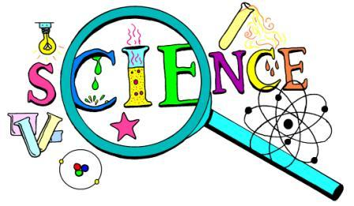
June 2020

