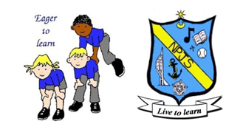
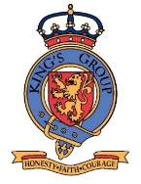
PSHE Curriculum Statement

Intent
The Health and Wellbeing Strategy, carried out by Portsmouth City Council, highlights a number of issues faced by those who live in the city, including our pupils. Compared to national figures, Portsmouth has a lower than average life expectancy, high levels of recorded violence, drug and alcohol misuse, along with 21% of Year 6 pupils being classified as obese. Therefore, we believe that it is crucial to deliver a high-quality personal, social, health and economic (PSHE) education. This will allow us to provide our pupils, from an early age, with the skills needed to live healthy, happy and independent lives as members of society. We aim to do this, whilst working in line with the 2014 National Curriculum for PSHE and the updated 2020 statutory guidance. Following this framework, we will support our pupils from the Foundation Stage through to Year 6, to identify, discuss and cope with moral, social and health-related issues. By the time our pupils leave Northern Parade, they will have gained crucial knowledge in three key areas: relationships education (including optional SRE for KS1 and KS2), health education and economic education including British Values and understanding different cultures.

Implementation
At Northern Parade Infant and Junior School, we have adopted the ‘Twinkl Life’ scheme which provides activities based around the three current areas for PSHE. These areas are Relationships, Health and Wellbeing and Living in the Wider World. The scheme is broken down into six half-termly blocks for each year group (two for relationships education; two for health education and two for societal and economic education.) This scheme should be used as a starting point for teachers and adapted to suit the pastoral needs of their cohort. This allows each lesson to be relevant, impactful and sensitive. Teachers should also be mindful of religion and other protected characteristics when delivering the lessons. Each area should be taught in an order that allows for meaningful links across the curriculum and links to our school Dragon Values should also be made throughout.
The children will have experiences of all three areas as they move through the key stages. Our programme of study will provide pupils with relevant, age appropriate content, which will allow for previous learnt skills to be built upon. Our PSHE education will provide accurate and relevant knowledge whilst giving the children opportunities to explore and challenge their own and others’ values, attitudes, beliefs and rights all in a safe environment.
In upper Key Stage 2, the scheme provides guidance and plans for sex and relationships education. This is non-statutory in primary schools, so parents must be aware of their rights to have their children removed from these lessons, prior to teaching. However, all other areas of relationship education are statutory and cannot be opted out of.

Impact
Our approach to the implementation of the PSHE curriculum results in engaging, informative and relevant lessons where children feel confident to share their understanding of key issues and how they are affected by them. We aim to provide all children with a well-rounded understanding of their own physical and mental health. We will educate them about the key relationships and support networks in their lives; and how they as individuals fit into the world around them.

Review
When:
By whom:
Agreed:

TEAMWORK RESILIENT INDEPENDENT CHALLENGE CREATIVE
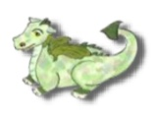
TRIO RUBY ISAAC CHARLIE CHRISTOPH

