05 March 2021
Dear Parents and carers
Monday is now fast approaching and in school there is a real sense of excitement. We are looking forward to having all the children back in their classrooms and learning alongside one another. As we said in our letter last week, our priority on return is ensuring that all children settle back into their classes feeling safe and secure. The children’s well-being will be the driving force of all our learning.
The safety of our school community is so important so we kindly ask that you are mindful of the guidance regarding social distancing when dropping off and picking up your children. We appreciate that these times of day will be challenging as we re-establish the routines from last September, but if we all work together we will be keeping everyone safe.
When arriving to collect your child we ask that you stick to the allocated staggered time slot to avoid high numbers of parents gathering at our gates. In order to aid social distancing can we request that only one adult per household comes to the school gates. If you arrive early please wait on the opposite side of the road. Again, we would like to remind you to wear face a coverings during these times as an extra safety measure. All staff in school wear face coverings when walking through communal areas and the children are now used to this additional safety measure.
Attendance has been a point of discussion and as from Monday 8th March it will be mandatory for your child to attend school unless your child has been issued a shielding letter, is isolating due to having COVID or a family member has COVID. We would like to reassure both parents and children that the school continues to review its risk assessment and we will always put additional safety measures in place when necessary to keep everyone safe at NPS.
Thank you for your time and understanding in these very challenging times. Please do not hesitate to contact the school if you have any concerns.
Take care and stay safe.
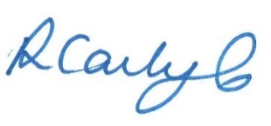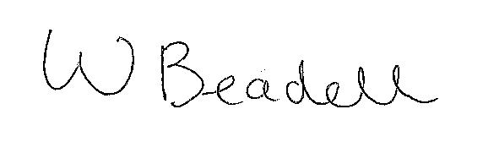
Mrs R Carlyle | Mr W Beadell
Head of School | Head of School
Northern Parade Infant School | Northern Parade Junior School

