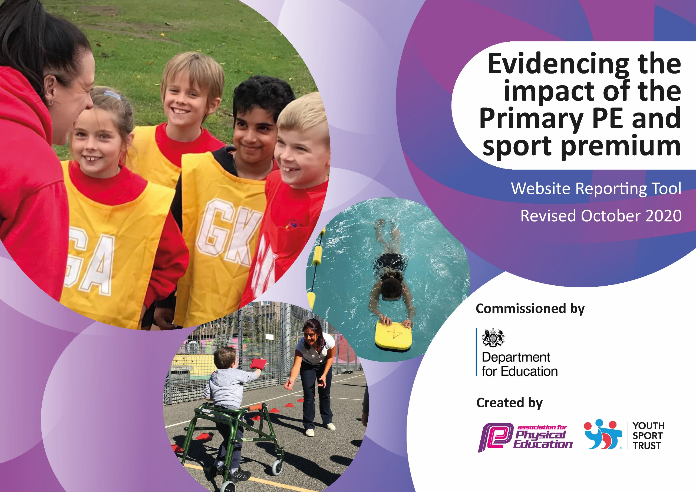
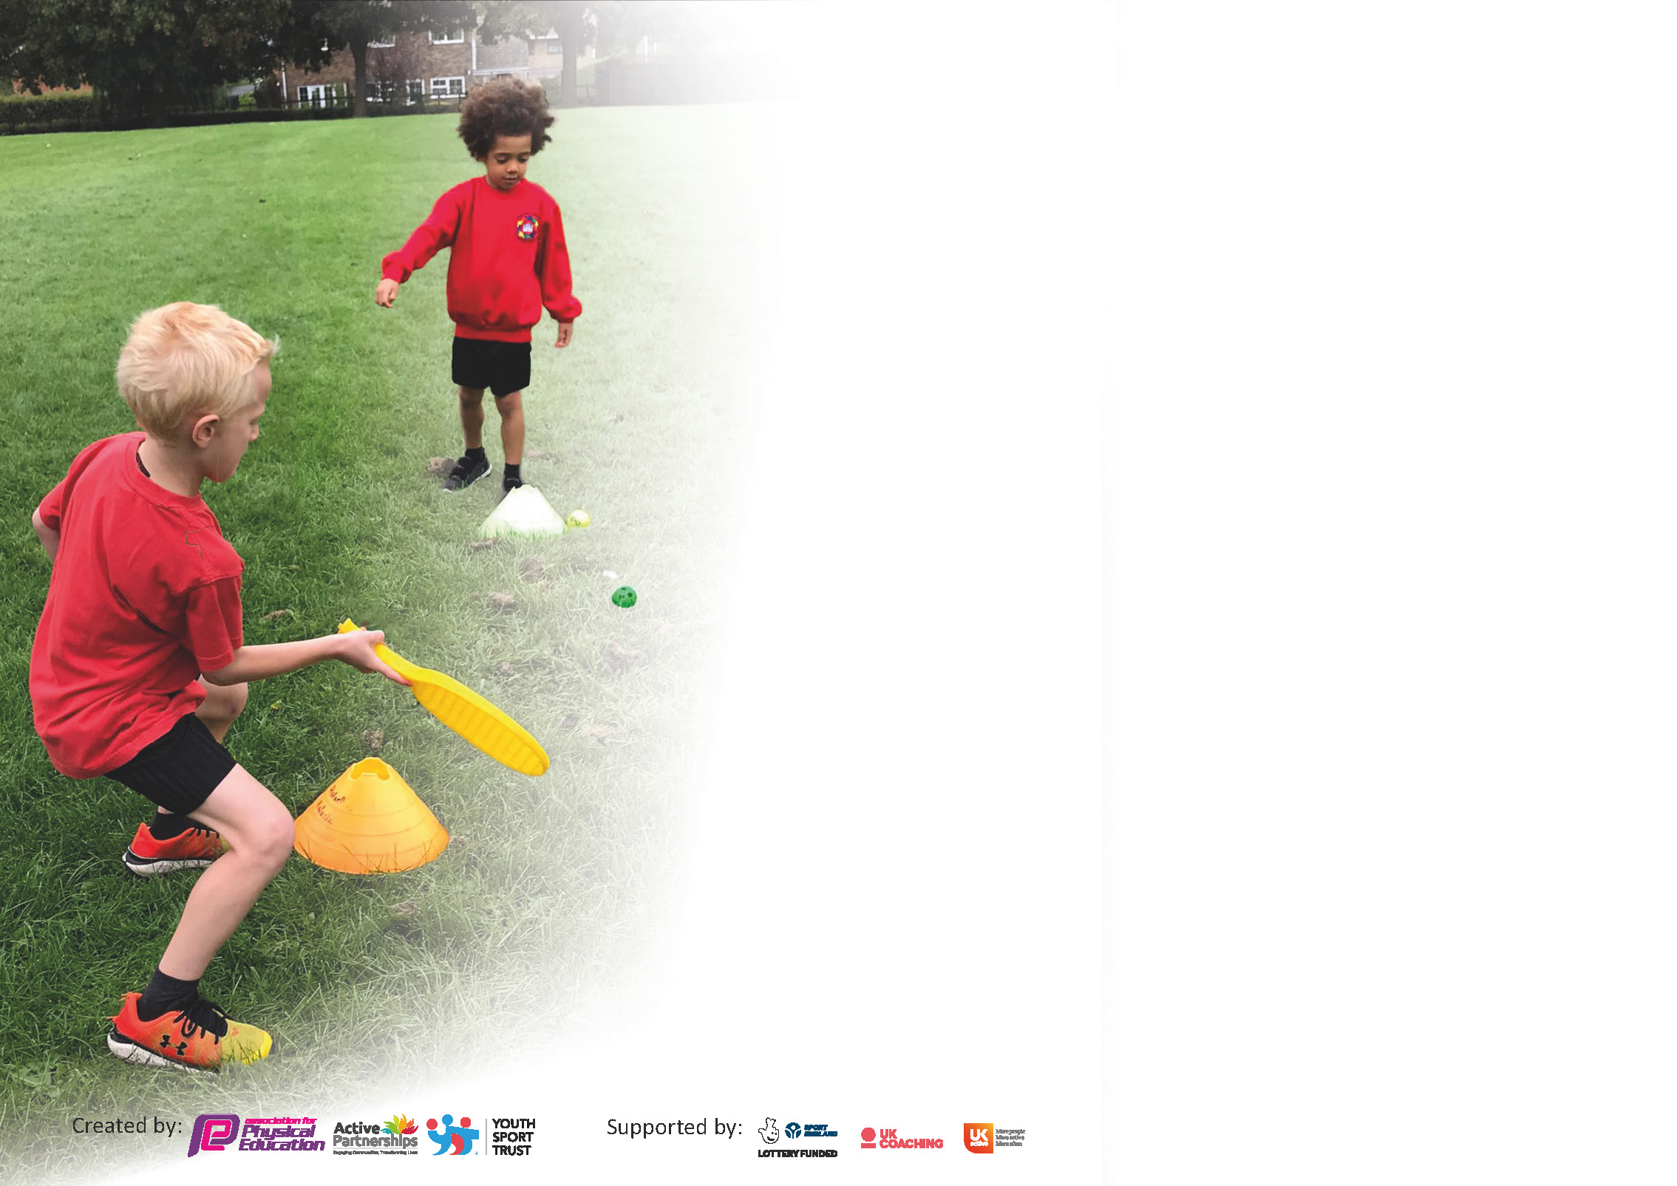

It is important that your grant is used effectively and based on school need. The Education Inspection Framework (Ofsted 2019 p64) makes clear there will be a focus on ‘whether leaders and those responsible for governors all understand their respective roles and perform these in a way that enhances the effectiveness of the school’.

Under the Quality of Education criteria (p41) inspectors consider the extent to which schools can articulate their curriculum (INTENT), construct their curriculum (IMPLEMENTATION) and demonstrate the outcomes which result (IMPACT).

To assist schools with common transferable language this template has been developed to utilise the same three headings which should make your plans easily transferable between working documents.

Schools must use the funding to make additional and sustainable improvements to the quality of Physical Education, School Sport and Physical Activity (PESSPA) they offer. This means that you should use
the Primary PE and sport premium to:

- Develop or add to the PESSPA activities that your school already offer
- Build capacity and capability within the school to ensure that improvements made now will benefit pupils joining the school in future years

Please visit gov.uk for the revised DfE guidance including the 5 key indicators across which schools should demonstrate an improvement. This document will help you to review your
provision and to report your spend. DfE encourages schools to use this template as an effective way of meeting the reporting requirements of the Primary PE and sport premium.

We recommend you start by reflecting on the impact of current provision and reviewing the previous spend.

Schools are required to publish details of how they spend this funding as well as on the impact it has on pupils’ PE and sport participation and attainment by the end of the summer term or by 31st July 2021 at the latest.

** In the case of any under-spend from 2019/20 which has been carried over this must be used and published by 31st March 2021.

We recommend regularly updating the table and publishing it on your website throughout the year. This evidences your ongoing self-evaluation of how you are using the funding to secure maximum, sustainable impact. Final copy must
be posted on your website by the end of the academic year and no later than the 31st July 2021. To see an example of how to complete the table please click HERE.
Created by: Supported by:

Please note: Although there has been considerable disruption in 2020 it is important that you publish details on your website of how you spend the funding - this is a legal requirement.
Support for review and reflection - considering the 5 key indicators from DfE, what development needs are a priority for your setting and your pupils now and why? Use the space below to reflect on previous spend and key achievements and areas for development.

N.B. In this section you should refer to any adjustments you might have made due to Covid-19 and how these will influence further improvement.
Key achievements to date until July 2020: | Areas for further improvement and baseline evidence of need:
Pre Covid achievements.  Daily involvement of all children in morning run.  Achieving Gold Sports Mark award for the past 3 years.  More involvement in sport from Girls (Target group).  High involvement of School sports competition.  Offering a wide range of sports in after school clubs.  PE lessons very inclusive allowing all children to participate in sports.  Post Covid-  Providing safe engaging PE lessons to our key worker children and vulnerable children at school. | Giving children the opportunity to take place in competitions (Virtually)  To identify sports talent and advise future steps/ signpost.  Encouraging children who are not engaging in sport to participate.  Developing the curriculum to ensure subject taught in safe but effective way.  Tackle lack of activity and weight gain due to lockdown within the school day.

Did you carry forward an underspend from 2019-20 academic year into the current academic year? YES Delete as applicable

If YES you must complete the following section
If NO, the following section is not applicable to you

If any funding from the academic year 2019/20 has been carried over you MUST complete the following section. Any carried over funding MUST be spent by 31 March 2021.
Academic Year: September 2020 to March 2021 | Total fund carried over: | Date Updated:  19.05.21
What Key indicator(s) are you going to focus on? |  |  |  | Total Carry Over Funding:
Intent | Implementation |  | Impact
Your school focus should be clear how you want to impact on your pupils. | Make sure your actions to achieve are linked to your intentions: | Carry over funding allocated: | Evidence of impact: How can you measure the impact on your pupils; you may have focussed on the difference that PE, SS & PA have made to pupils re-engagement with school. What has changed?: | Sustainability and suggested next steps and how does this link with the key indicators on which you are focussing this academic year?  .

Meeting national curriculum requirements for swimming and water safety.

N.B Complete this section to your best ability. For example you might have practised safe self-rescue techniques on dry land.
What percentage of your current Year 6 cohort swim competently, confidently and proficiently over a distance of at least 25 metres?  N.B. Even though your pupils may swim in another year please report on their attainment on leaving primary school at the end of the summer term 2020. | %
What percentage of your current Year 6 cohort use a range of strokes effectively [for example, front crawl, backstroke and breaststroke]? | %
What percentage of your current Year 6 cohort perform safe self-rescue in different water-based situations? | %
Schools can choose to use the Primary PE and sport premium to provide additional provision for swimming but this must be for activity over and above the national curriculum requirements. Have you used it in this way? | Yes/No

Action Plan and Budget Tracking
Capture your intended annual spend against the 5 key indicators. Clarify the success criteria and evidence of impact that you intend to measure to evaluate for pupils today and for the future.

Academic Year: 2020/21 | Total fund allocated: £20,800 | Date Updated:19/05/21
Key indicator 1: The engagement of all pupils in regular physical activity – Chief Medical Officers guidelines recommend that primary school pupils undertake at least 30 minutes of physical activity a day in school |  |  |  | Percentage of total allocation:
 |  |  |  | 12.5%
Intent | Implementation |  | Impact
Your school focus should be clear what you want the pupils to know and be able to do and about  what they need to learn and to  consolidate through practice: | Make sure your actions to achieve are linked to your intentions: | Funding allocated: | Evidence of impact: what do pupils now know and what can they now do? What has changed?: | Sustainability and suggested next steps:
The hiring of professional coach to offer extra on top of curriculum provison .  Subsidize PE kit | Funding to allow 5 children who do not engage in sport from each year group to take part in after school clubs. Coach to take lunch time activities. Teachers working with Coach to develop confidence in teaching. Coach to take children to after school competitions. Qualified Gym teacher to help implement effect gym lessons.  PE kit no longer at school so will need to be ordered from website for children who do not have PE kits. Allows all to take place and use the correct kit. | £2600  £400 | Due to Covid, child weight gain has increased. Each half term 20 children will benefit from attending an after school club free of charge. Children able to attend after school competitions with use of our sports coach.  Our coach with his expertise will be able to help teachers with their CPD and make teachers more confident to take PE lessons.  Continue to provide PE kits for children who do not have the right equipment. Right PE kit means that all pupils can take part in lessons. | Communication between Sports Coaches & Teaching Staff is important to ensure that teachers do not become de-skilled & so that there is accurate assessment, recording & reporting.  Encourage pupils provided with free PE kit to look after & value it. Pass on second-hand to others when it is grown out of.
Key indicator 2: The profile of PESSPA being raised across the school as a tool for whole school improvement |  |  |  | Percentage of total allocation:
 |  |  |  | 29%
Intent | Implementation |  | Impact
Your school focus should be clear what you want the pupils to know and be able to do and about  what they need to learn and to  consolidate through practice: | Make sure your actions to achieve are linked to your intentions: | Funding allocated: | Evidence of impact: what do pupils now know and what can they now do? What has changed?: | Sustainability and suggested next steps:
A clearer pupil voice regarding the teaching of sport.  Providing areas where effectively lessons can take place | As part of our service agreement. We will have Madeleine Campbell continue to work with our Sports Leader to develop our Sports council and Change for Life ambassadors. We will look at ways on how to achieve this virtually.  Upgrade playground markings to ensure that areas can be used for PE lessons. | As part of our service level agreement.  £6000 | Pupils to have a clear voice in the PE provision in sport. Children to engage better in lessons due to have a say on what is provided.  This will allow our PE lessons to take place more effectively with clearer courts for sports activities. This should also encourage children to be more active at break-time with a more engaging area to play. | Pupil Voice & initiative related to PE & Sport becomes the norm.  Monitor durability of playground & plan in advance for next upgrade.

Key indicator 3: Increased confidence, knowledge and skills of all staff in teaching PE and sport |  |  |  | Percentage of total allocation:
 |  |  |  | 2%
Intent | Implementation |  | Impact
Your school focus should be clear | Make sure your actions to | Funding | Evidence of impact: what do | Sustainability and suggested
what you want the pupils to know | achieve are linked to your | allocated: | pupils now know and what | next steps:
and be able to do and about | intentions: |  | can they now do? What has
what they need to learn and to |  |  | changed?:
consolidate through practice:
Pay for cover to enable staff to undertake CPD opportunities.  . | High quality and motivating gymnastic lessons catering for all abilities. Opportunity for staff to provide training in other sports to allow us to compete in a wide range of sporting competition. This will allow cover for teachers to observe gym lessons. | £500 | Helping staff develop skills and sports providers to feel confident in and to continue to provide a high-quality lesson. | Staff gain confidence & skills to deliver own PE lessons or extra-curricular clubs. Lesson observations will identify if further training is needed.
Key indicator 4: Broader experience of a range of sports and activities offered to all pupils |  |  |  | Percentage of total allocation:
 |  |  |  | 28%
Intent | Implementation |  | Impact
Your school focus should be clear | Make sure your actions to | Funding | Evidence of impact: what do | Sustainability and suggested
what you want the pupils to know | achieve are linked to your | allocated: | pupils now know and what | next steps:
and be able to do and about | intentions: |  | can they now do? What has
what they need to learn and to |  |  | changed?:
consolidate through practice:
Provide a range of sports to all pupils.  End of year activity week | Purchase new sports equipment.  Look at PE equipment across the school.  Due to Covid, children have not had many experiences or trips. Money would be allocated to each year group to be able offer trips or visitors to come in.  £4800 equates to £10 per child across the school or £1200 per year group.  Money would used to take children on trips to local areas, paying for minibus or coach hire. Allowing sports coaches to come in and take sport sessions during our activity week. We will also use this morning to pay for any equipment needed to engage in these activities. | £1000  £4800 | A wide range of equipment has been  purchased. Including athletic equipment  which broadens what the children learn  and also helps them prepare for competitions.  This will give children a wide range of active experiences that they have missed out in this year due to Covid. Children will be able to have tried new activites or experiences. | Monitor condition & use of equipment.  Look at effectiveness and see if this can be used again next year.

Key indicator 5: Increased participation in competitive sport |  |  |  | Percentage of total allocation:
 |  |  |  | 26%
Intent | Implementation |  | Impact
Your school focus should be clear | Make sure your actions to | Funding | Evidence of impact: what do | Sustainability and suggested
what you want the pupils to know | achieve are linked to your | allocated: | pupils now know and what | next steps:
and be able to do and about | intentions: |  | can they now do? What has
what they need to learn and to |  |  | changed?:
consolidate through practice:
Allowing more children to participate in competition.  Continue to compete in a range of sports as a school.-  Extra swimming provision | Contribute towardsrunning costs of 3 minibuses to allow transport to and from a wider variety of competitions and activities. (Being optimistic that we will be able to engage in sport competitions in summer term.)  Portsmouth School Sports Partnership  Sport Services.  Offer swimming lessons to those that have missed out due to Covid. | £1,000  £2500.  £2000 | To continue to compete in a wide range of sporting activities and competition.  Service level agreement with Sport Services  to ensure an enriched and varied opportunities for all  children to take part in sport.  Ensuring that all the children have a chance  To swim whilst being at the school. | Ensure sufficient staff are trained & qualified to drive minibuses.  Monitor participation in PE & Sports. Try to involving as many children in competitive sport throughout their time at Northern Parade  Keep track of who has swimming lessons in the school.

Signed off by
Head Teacher:
Date:
Subject Leader:
Date:
Governor:
Date:

