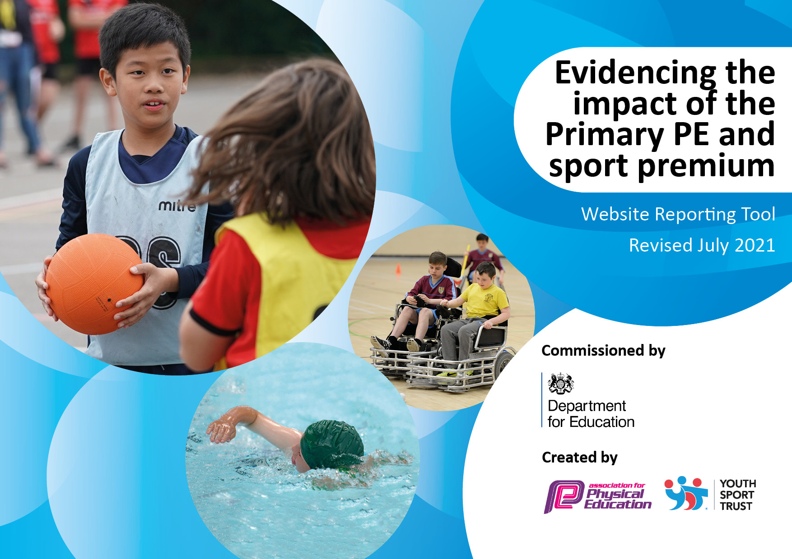
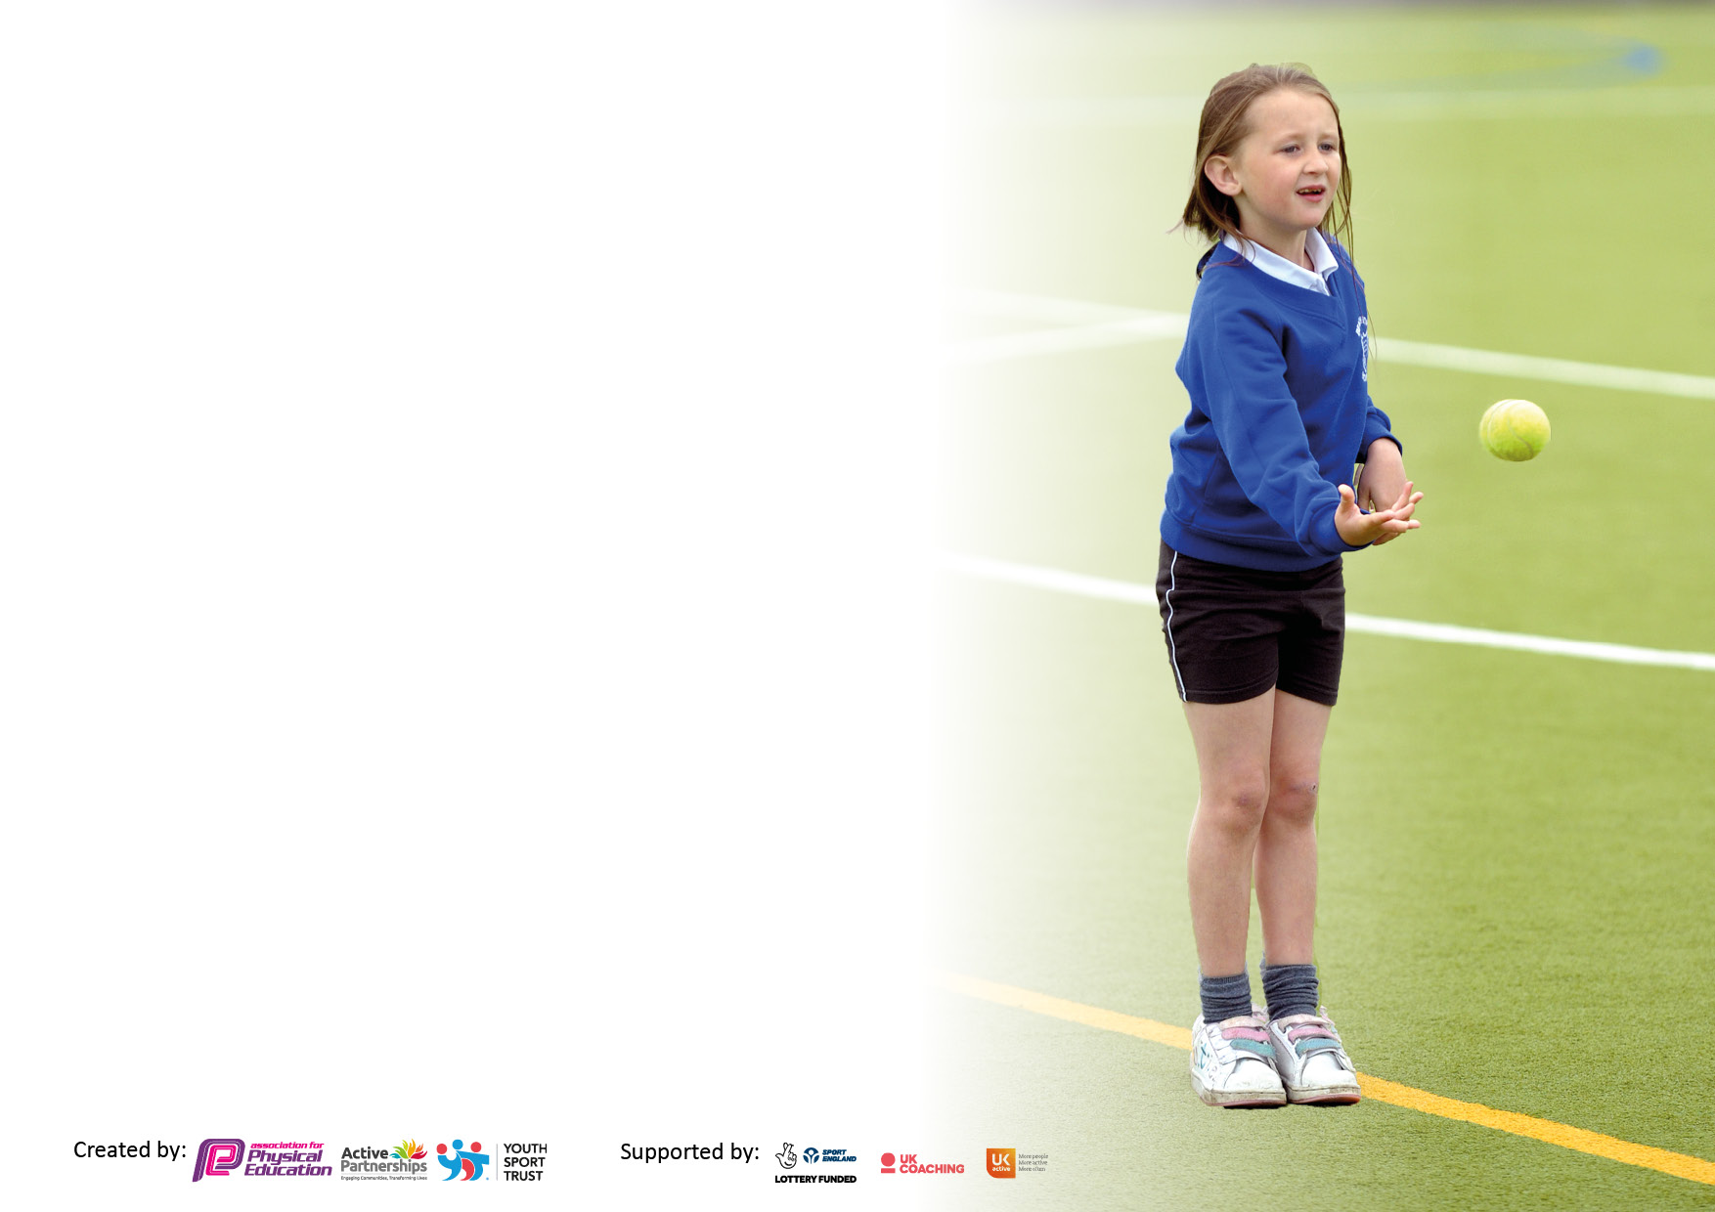

It is important that your grant is used effectively and based on school need. The Education Inspection Framework makes clear there will be a focus on ‘whether leaders and those responsible for governors all understand their respective roles and perform these in a way that enhances the effectiveness of the school’.

Under the Quality of Education Ofsted inspectors consider:
Intent - Curriculum design, coverage and appropriateness
Implementation - Curriculum delivery, Teaching (pedagogy) and Assessment
Impact - Attainment and progress

To assist schools with common transferable language this template has been developed to utilise the same three headings which should make your plans easily transferable between working documents.

Schools must use the funding to make additional and sustainable improvements to the quality of Physical Education, School Sport and Physical Activity (PESSPA) they offer. This means that you should use the Primary PE and sport premium to:

- Develop or add to the PESSPA activities that your school already offer
- Build capacity and capability within the school to ensure that improvements made now will benefit pupils joining the school in future years
- The Primary PE and sport premium should not be used to fund capital spend projects; the school’s budget should fund these.

Pleasevisitgov.ukfortherevisedDfEguidanceincludingthe5keyindicatorsacrosswhichschoolsshoulddemonstrate animprovement.Thisdocumentwillhelpyoutoreviewyourprovisionandtoreportyourspend.DfEencouragesschools to use this template as an effective way of meeting the reporting requirements of the Primary PE and sport premium.

We recommend you start by reflecting on the impact of current provision and reviewing the previous spend.

Schools are required to publish details of how they spend this funding, including any under-spend from 2019/2020, as well as on the impact it has on pupils’ PE and sport participation and attainment. All funding must be spent by 31st July 2022.

We recommend regularly updating the table and publishing it on your website throughout the year. This evidences your ongoing self-evaluation of how you are using the funding to secure maximum, sustainable impact. Final copy must be posted on your website by the end of the academic year and no later than the 31st July 2021. To see an example of how to complete the table please click HERE.

Details with regard to funding
Please complete the table below.

Total amount carried over from 2019/20 | £0
Total amount allocated for 2020/21 | £19600
How much (if any) do you intend to carry over from this total fund into 2021/22? | £4000
Total amount allocated for 2021/22 | £23600
Total amount of funding for 2021/22. To be spent and reported on by 31st July 2022. | £23600
Swimming Data
Please report on your Swimming Data below.

Meeting national curriculum requirements for swimming and water safety.  N.B. Complete this section to your best ability. For example you might have practised safe self-rescue techniques on dry land which you can then transfer to the pool when school swimming restarts.  Due to exceptional circumstances priority should be given to ensuring that pupils can perform safe self rescue even if they do not fully meet the first two requirements of the NC programme of study | N/A (Infant school)
What percentage of your current Year 6 cohort swim competently, confidently and proficiently over a distance of at least 25 metres?  N.B. Even though your pupils may swim in another year please report on their attainment on leaving primary school at the end of the summer term 2020.  Please see note above | %
What percentage of your current Year 6 cohort use a range of strokes effectively [for example, front crawl, backstroke and breaststroke]?  Please see note above | %
What percentage of your current Year 6 cohort perform safe self-rescue in different water-based situations? | %
Schools can choose to use the Primary PE and sport premium to provide additional provision for swimming but this must be for activity over and above the national curriculum requirements. Have you used it in this way? | No

Action Plan and Budget Tracking
Capture your intended annual spend against the 5 key indicators. Clarify the success criteria and evidence of impact that you intend to measure to evaluate for pupils today and for the future.

Academic Year: 2020/21 | Total fund allocated: | Date Updated:
Key indicator 1: The engagement of all pupils in regular physical activity – Chief Medical Officers guidelines recommend that primary school pupils undertake at least 30 minutes of physical activity a day in school |  |  |  | Percentage of total allocation:
 |  |  |  | 23%
Intent | Implementation |  | Impact
Your school focus should be clear what you want the pupils to know and be able to do and about  what they need to learn and to  consolidate through practice: | Make sure your actions to achieve are linked to your intentions: | Funding allocated: | Evidence of impact: what do pupils now know and what can they now do? What has changed?: | Sustainability and suggested next steps:
1.The hiring of professional coach to offer extra on top of curriculum.  2.Subsidize PE kit and sports equipment | Funding to allow 5 children who do not engage in sport from each year group to take part in after school clubs. Sports coach to offer Lunch time activities. Teachers working with Coach to develop confidence in teaching. Coach to take children to after school competitions. Qualified Gym teacher to help implement effect gym lessons. The Coach with their expertise will also help us as we develop the curriculum across KS1  PE kit no longer at school so will need to be ordered from website for children who do not have PE kits. Allows all to take place and use the correct kit. | £3600  £1000 | 1.  15 children every half term has enjoyed and been able to take part in a club that they would not have been able to due to costs. Gym curriculum has started to be adapted and other teachers are becoming more confident in delivering gym lessons themselves. This needs to continue to be developed.  2. 40 children have benefited from PE kits across the infant school and this has meant being able to take part in lessons. | 1. Continue to develop the curriculum with help of professional coach. Use of coach for CPD and to take children to extra after school activities.  2. Not all funding spent, next year to adapt money to be spent. Continue to fund for children to have kit who do not have kit. Encourage children to look after kit.
Key indicator 2: The profile of PESSPA being raised across the school as a tool for whole school improvement |  |  |  | Percentage of total allocation:
 |  |  |  | 5%
Intent | Implementation |  | Impact
Your school focus should be clear what you want the pupils to know and be able to do and about  what they need to learn and to  consolidate through practice: | Make sure your actions to achieve are linked to your intentions: | Funding allocated: | Evidence of impact: what do pupils now know and what can they now do? What has changed?: | Sustainability and suggested next steps:
A clearer pupil voice regarding the teaching of sport. | As part of our service agreement. We will have Madeleine Campbell continue to work with our Sports Leaders in the junior school to develop our Sports council and Change for Life ambassadors. We aim to set a sport council in the infant school | £1000 | This has started to be developed and children starting to share ideas, more challenging in a Covid impacted year. We were able to run a Fun Day for all children across the Key Stage and feedback and ideas received on how to improve next year. | Develop Pupil Voice & initiative related to PE & Sport becomes the norm. Training junior sports leaders to run lunch time clubs. Yearly survey to inform planning.

Key indicator 3: Increased confidence, knowledge and skills of all staff in teaching PE and sport |  |  |  | Percentage of total allocation:
 |  |  |  | 15%
Intent | Implementation |  | Impact
Your school focus should be clear | Make sure your actions to | Funding | Evidence of impact: what do | Sustainability and suggested
what you want the pupils to know | achieve are linked to your | allocated: | pupils now know and what | next steps:
and be able to do and about | intentions: |  | can they now do? What has
what they need to learn and to |  |  | changed?:
consolidate through practice:
Pay for cover to enable staff to undertake CPD opportunities. | We will use our sports coach to help develop curriculum and enable Infant staff to become more confident teaching High quality and motivating gymnastic lessons catering for all abilities. Part of funding will be used to cover teachers to observe lessons. | £3000 | This has begun to take place and Infant staff are starting to become more confident teaching gym lessons. Gym Equipment is being used to help enhance the experience of the children | Staff gain confidence & skills to deliver own PE lessons or extra-curricular clubs. Lesson observations will identify if further training is needed.
Key indicator 4: Broader experience of a range of sports and activities offered to all pupils |  |  |  | Percentage of total allocation:
 |  |  |  | 34%
Intent | Implementation |  | Impact
Your school focus should be clear | Make sure your actions to | Funding | Evidence of impact: what do | Sustainability and suggested
what you want the pupils to know | achieve are linked to your | allocated: | pupils now know and what | next steps:
and be able to do and about | intentions: |  | can they now do? What has
what they need to learn and to |  |  | changed?:
consolidate through practice:
Additional achievements:  1.Provide a range of sports to all pupils.  2.Olympic Dance Workshop  3. End of year activity week | 1. Purchase new sports equipment.  Look at PE equipment across the school. More money to be spent on this area. Equipment in the past kept at the junior school. Infant school to now have own equipment to ensure lessons can take place effectively.  2.An outside company will come and deliver a dance class linked to the Olympics.  3.Due to Covid, children have not had many experiences or trips. Money would be allocated to each year group to be able offer trips or visitors to come in.  £3600 equates to £10 per child across the school or £1200 per year group. | £2000  £1000  £3600 | 1.Sports equipment has been purchased, including more athletic equipment allowing children to take part in a wide range of sports.  2. Children loved taking part in the Olympic workshop, they were inspired and learnt about Japanese culture.  3. Due to Covid and two year groups having to self isolate. We did not manage to do this so money was not spent. | 1.Monitor condition & use of equipment.  2.  Rebook for next year with a different workshop.  3. Aim to do this year and evaluate effectiveness.

Key indicator 5: Increased participation in competitive sport |  |  |  | Percentage of total allocation:
 |  |  |  | 23%
Intent | Implementation |  | Impact
Your school focus should be clear | Make sure your actions to | Funding | Evidence of impact: what do | Sustainability and suggested
what you want the pupils to know | achieve are linked to your | allocated: | pupils now know and what | next steps:
and be able to do and about | intentions: |  | can they now do? What has
what they need to learn and to |  |  | changed?:
consolidate through practice:
1.Allowing more children to participate in competition.  2. Continue to compete in a range of sports as a school. | 1.Contribute towards running costs of 3 minibuses to allow transport to and from a wider variety of competitions and activities.  2. Sign up to the silver level of Portsmouth School Sports Partnership  Sport Services. | £2000  £2400. | 1.This has been more challenging due to Covid and no physical competitions. We have taken part in a few virtual challenges. Even though we have not used minibuses for competitions they have still needed to be insured and had MOT.  2. Schools Sports partnership has meant we were still able to compete virtual. Information shared on improving wellbeing of children and CPD for staff on how to deliver a curriculum post Covid. | 1.Ensure sufficient staff are trained & qualified to drive minibuses.  2.Monitor infant participation in PE & Sports.

Signed off by
Head Teacher:
Date:
Subject Leader:
Date:
Governor:
Date:

