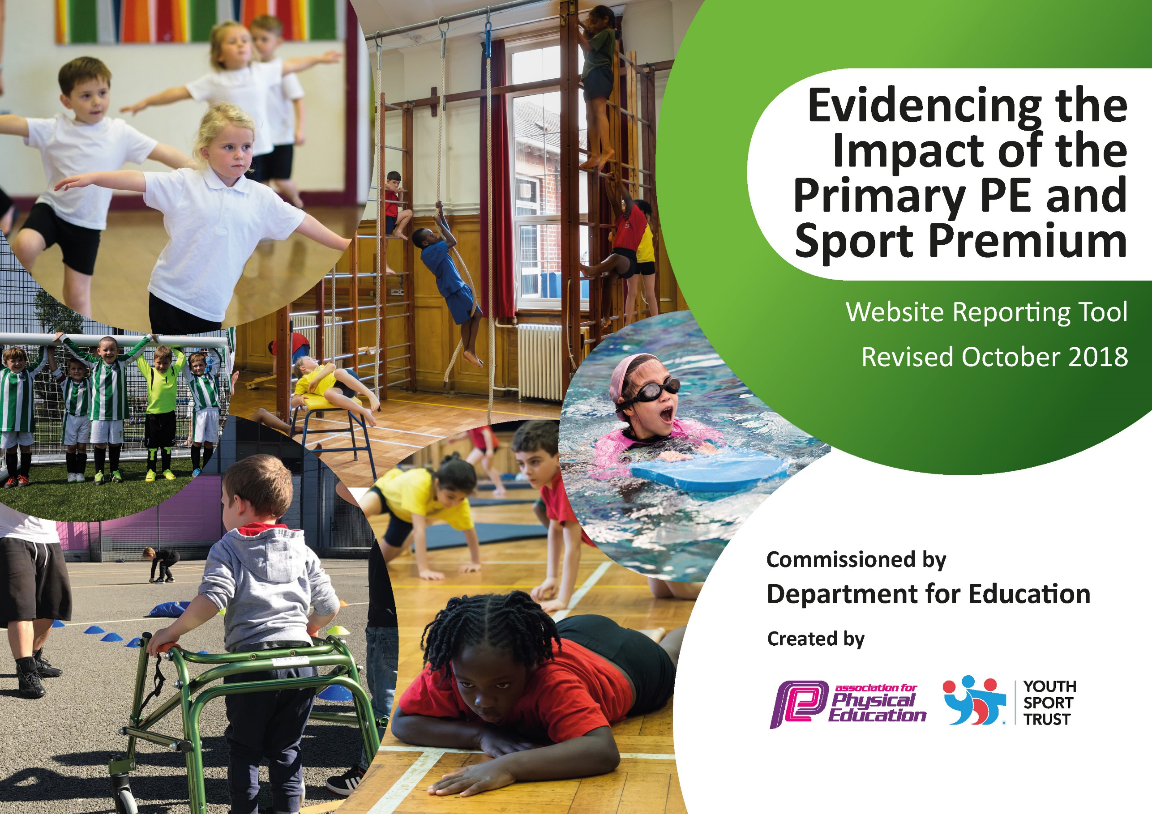
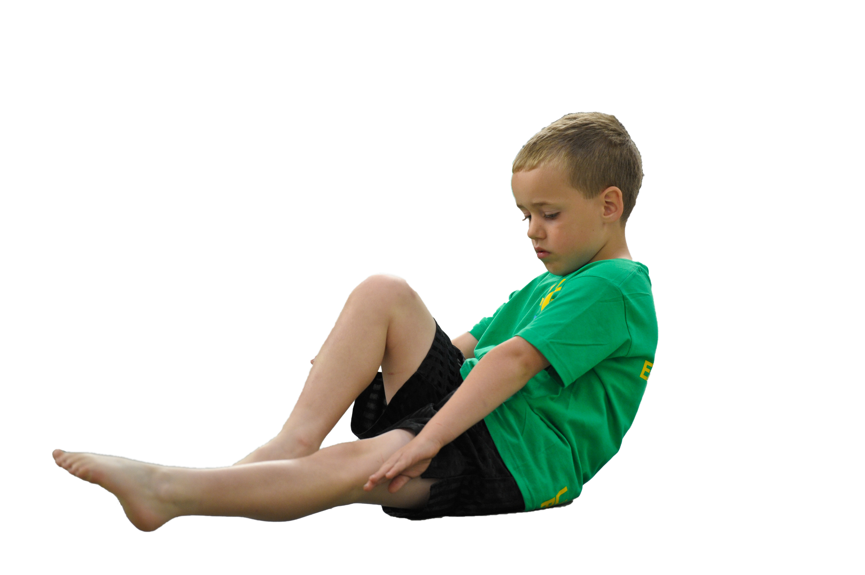
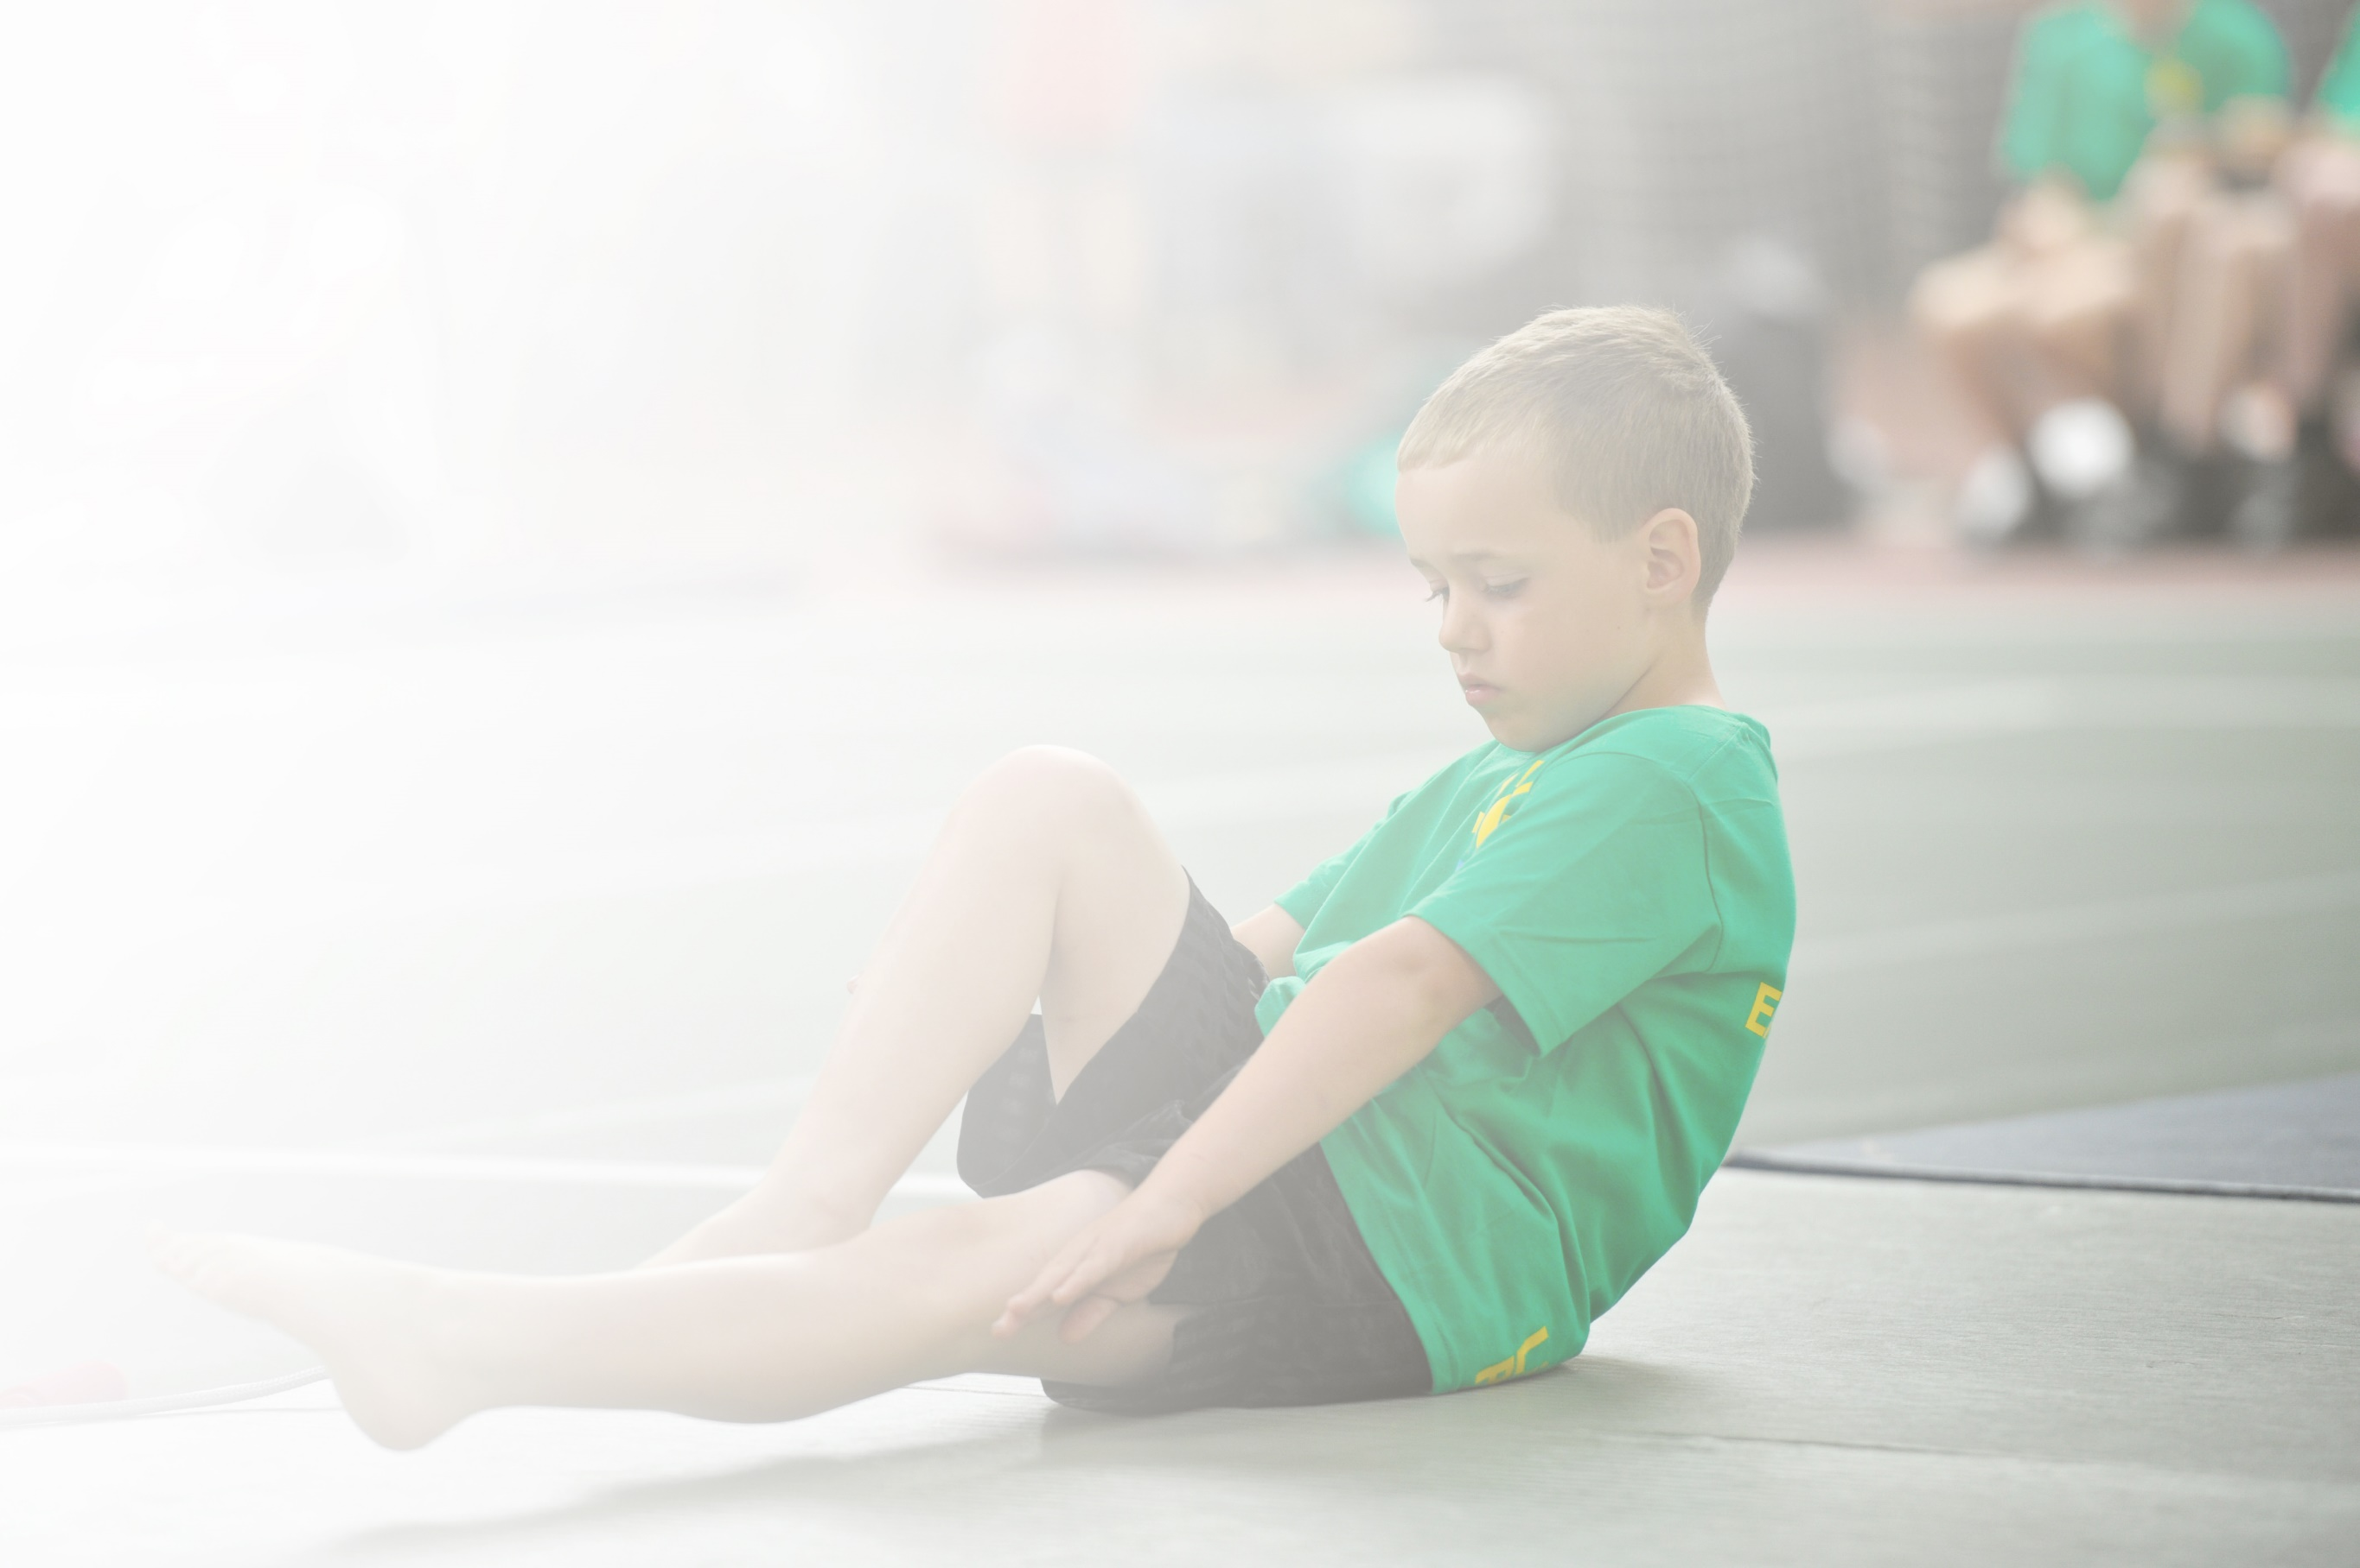
Schools must use the funding to make additional and sustainable improvements to the quality of Physical Education, Sport and Physical Activity (PESPA) they offer. This means that you should use the Primary PE and Sport Premium to:

- Develop or add to the PESPA activities that your school already offer
- Build capacity and capability within the school to ensure that improvements made now will benefit pupils joining the school in future years

Please visit gov.uk for the revised DfE guidance including the 5 key indicators across which schools should demonstrate an improvement. This document will help you to review your provision and to report
your spend. DfE encourages schools to use this template as an effective way of meeting the reporting requirements of the Primary PE and Sport Premium.

We recommend you start by reflecting on the impact of current provision and reviewing the previous
spend. Under the Ofsted Schools Inspection Framework, inspectors will assess how effectively leaders use the Primary PE and Sport Premium and measure its impact on outcomes for pupils, and how effectively governors hold them to account for this.

Schools are required to publish details of how they spend this funding as well as on the impact it has on pupils’ PE and sport participation and attainment by the end of the summer term or by 31 July 2019 at the
latest.
We recommend regularly updating the table and publishing it
on your website throughout the year, as evidence of your
ongoing review into how you are using the money to
secure maximum, sustainable impact. To see an
example of how to complete the table please
click HERE.

Support for review and reflection - considering the 5 key indicators from DfE, what development needs are a priority for your setting and your students now and why? Use the space below to reflect on previous spend, identify current need and priorities for the future.

Key achievements to date: | Areas for further improvement and baseline evidence of need:
Daily involvement of all children in morning run.  Achieving Gold Sports Mark award for the past 3 years.  More involvement in sport from Girls (Target group).  High involvement of School sports competition.  Offering a wide range of sports in after school clubs.  PE lessons very inclusive allowing all children to participate in sports. | Continue to develop the clubs that we deliver after school.  To identify sports talent and advise future steps/ signpost.  Encouraging children who are not engaging in sport to participate .

Meeting national curriculum requirements for swimming and water safety | Please complete all of the below:
What percentage of your current Year 6 cohort swim competently, confidently and proficiently over a distance of at least 25 metres?  N.B. Even though your children may swim in another year please report on their attainment on leaving  primary school. | 70%
What percentage of your current Year 6 cohort use a range of strokes effectively [for example, front crawl, backstroke and breaststroke]? | 65%
What percentage of your current Year 6 cohort perform safe self-rescue in different water-based situations? | 80%
Schools can choose to use the Primary PE and Sport Premium to provide additional provision for swimming but this must be for activity over and above the national curriculum requirements. Have you used it in this way? | No

Action Plan and Budget Tracking
Capture your intended annual spend against the 5 key indicators. Clarify the success criteria and evidence of impact that you intend to measure to evaluate for students today and for the future.

Academic Year: 2018/19 | Total fund allocated: £40,320 | Date Updated:18/07/2019
Key indicator 1: The engagement of all pupils in regular physical activity – Chief Medical Officer guidelines recommend that primary school children undertake at least 30 minutes of physical activity a day in school |  |  |  | Percentage of total allocation:
 |  |  |  | 73.25 %
School focus with clarity on intended impact on pupils: | Actions to achieve: | Funding allocated: | Evidence and impact: | Sustainability and suggested next steps:
- The hiring of professional coach.  - To hire a dance teacher.  - Subsidize PE kit | Professional, qualified sports coaches  Taking all children for high quality games lessons.  All children taking part in high quality Dance lessons.  Provide PE kit for disadvantaged pupils | £18,563  £10,000  £500 | Children working in teams and individual challenges. Children developing a passion for sport through a variety of sports disciplines. We will also aim to offer 50% of the school a 3rd hour of PE. Lesson observations have shown the high standard of teaching.  Professional dance coach to support dance lessons and our creative curriculum. Children developing and understanding of performance for a purpose, working as a team and performing to an audience.  Right PE kit means that all pupils can take part in lessons. | Continue to develop the sports that are offered and the development of Gym within the curriculum.  Teachers to identify any children that will need a PE kit to take part in sport in a timely manner.
Key indicator 2: The profile of PESSPA being raised across the school as a tool for whole school improvement |  |  |  | Percentage of total allocation:
 |  |  |  | %
School focus with clarity on intended impact on pupils: | Actions to achieve: | Funding allocated: | Evidence and impact: | Sustainability and suggested next steps:
- A clearer pupil voice regarding the teaching of sport. | As part of our service agreement. We will have Madeleine Campbell work with our Sports Leader to develop our Sports council and Change for Life ambassadors. | £500 | Pupils to have a clear voice in the PE provision in sport. | Continue training of children to be involved with the sport planning and aiming to run their own session.

Key indicator 3: Increased confidence, knowledge and skills of all staff in teaching PE and sport |  |  |  | Percentage of total allocation:
 |  |  |  | 13.75%
School focus with clarity on intended  impact on pupils: | Actions to achieve: | Funding  allocated: | Evidence and impact: | Sustainability and suggested  next steps:
- Pay for cover to enable staff to undertake CPD opportunities.  - Providing areas where effectively lessons can take place. | High quality and motivating gymnastic lessons catering for all abilities.  Upgrading Markings of playground and outdoors. | £500  £5000 | Children gaining greater knowledge of how the body works and how to keep healthy and have high quality lessons.  Playground markings will be updated which will keep children engaged and entertained at break times. Most important it will make a positive impact and support PE lessons being run. | Keep track of staff skill set and sent on future training if necessary.
Key indicator 4: Broader experience of a range of sports and activities offered to all pupils |  |  |  | Percentage of total allocation:
 |  |  |  | 0.5%
School focus with clarity on intended  impact on pupils: | Actions to achieve: | Funding  allocated: | Evidence and impact: | Sustainability and suggested  next steps:
- To engage more children into sport and afterschool clubs.  - Provide a range of sports to all pupils. | To support and encourage children who do not take part in sport to engage.  Purchase new sports equipment. | £200  £500 | A broader range of sports offered.  A wide range of equipment has been  purchased. Including athletic equipment  which broadens what the children learn  and also helps them prepare for competitions. | A survey has been untaken asking children which clubs they would like to attend.  As above. We will need to buy equipment to ensure this happens.
Key indicator 5: Increased participation in competitive sport |  |  |  | Percentage of total allocation:
 |  |  |  | 12.5%
School focus with clarity on intended  impact on pupils: | Actions to achieve: | Funding  allocated: | Evidence and impact: | Sustainability and suggested  next steps:
- Allowing more children to participate in competition.  - Continue to compete in a range of sports as a school. | Contribute towards the purchase and running costs of 3 minibuses to allow transport to and from a wider variety of competitions and activities.  Portsmouth School Sports Partnership  Sport Services. | £2,000  £3000. | We have increased our sports we compete in.  Service level agreement with Sport Services to ensure an enriched and varied opportunities for all pupils to  experience. Extra sports activities for this  year included, tennis, hockey and football. | To aim that every child has the opportunity to take part in a sports competition.  Continue to compete in a wide range of sports.

