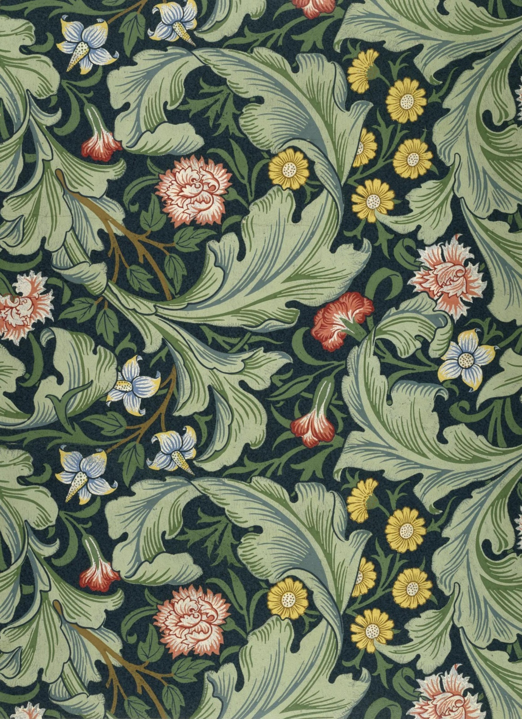
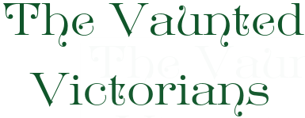
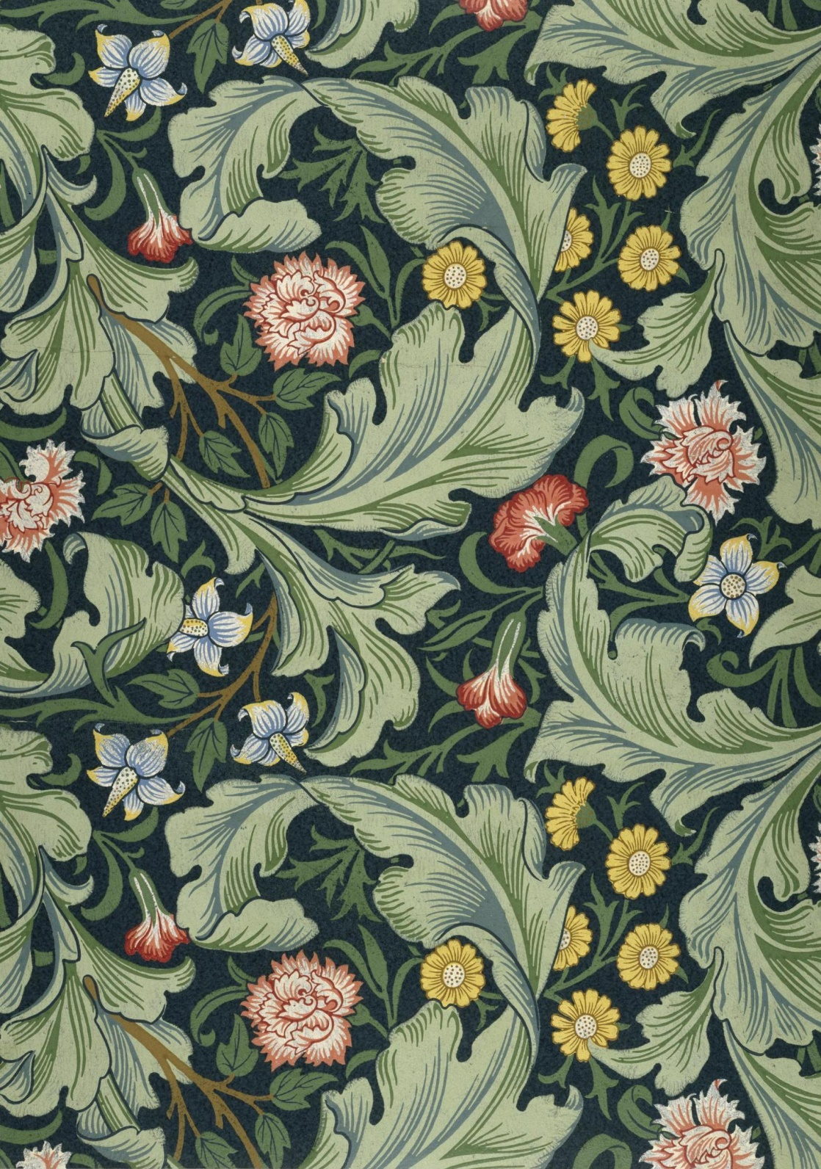






Homework
In year 6, we set Maths and spelling homework weekly, which is due in on Fridays. We also expect that reading is done daily, as well as achieving 300 correct answers on TTRockstars per week. While we often don’t set specific Topic homework, we love to receive any learning that pupils complete at home, and any outside learning will be celebrated and displayed within the year group. Homework support is offered in lunch time homework club on Tuesdays and Thursdays.
We will be using teamwork during our Topic when we are completing group work.
Our pupils demonstrate independence while completing their homework, independent writing, and self-directed tasks.
In Year 6, our children are excited to take on a challenge in every lesson, especially Topic!
We show resilience when we are learning new skills.
Our students get the chance to show off their creativity through our creative curriculum, making links, through Topic, to English, Maths and Reading.

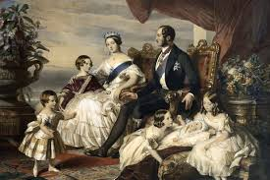

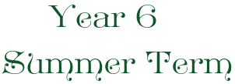

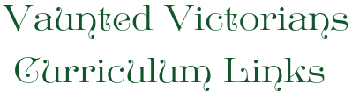
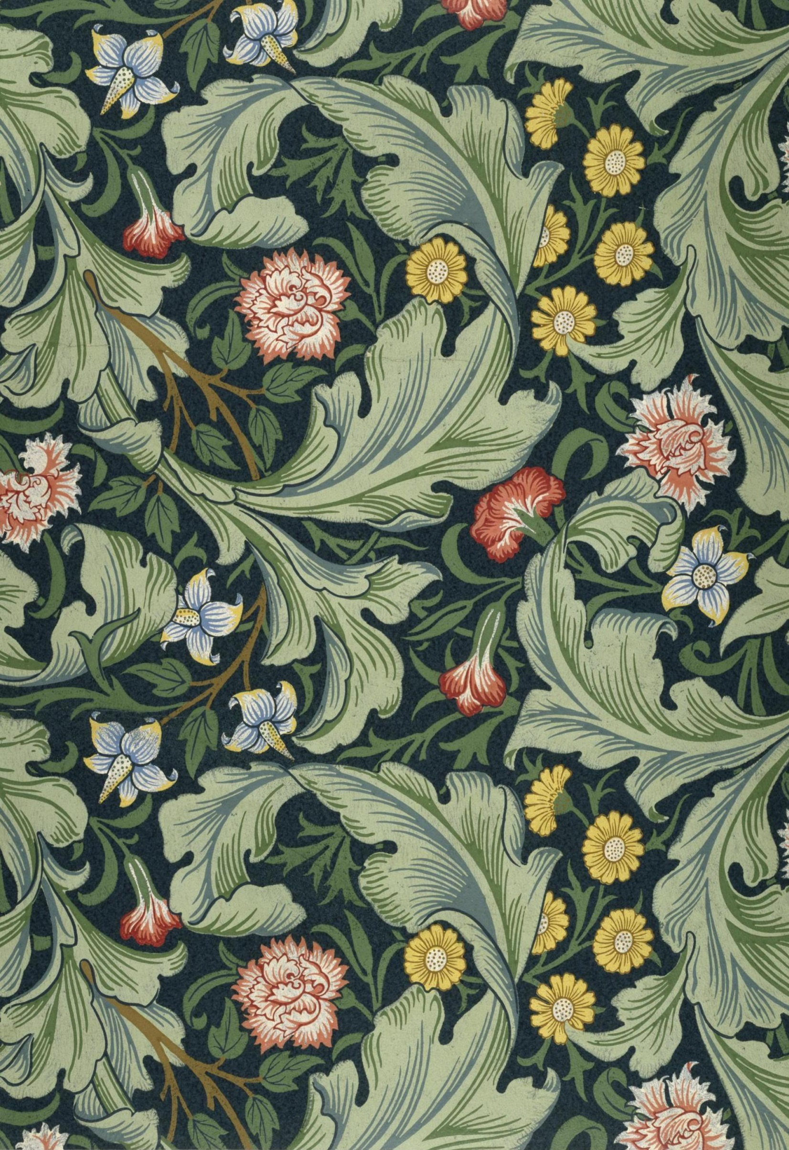
RE
Our RE coverage this term will be covering the topics of Prophet-hood within the Islamic faith, and a comparison between what worship looks like for Christians and Muslims.
PHSE
In PSHE, we will be completing units based around ‘growing and changing’ and ‘my feelings’. These topics will help pupils prepare for their transition to senior school.
Spanish
In Spanish, we will be using the vocabulary we have learnt this year to write descriptive texts with growing complexity.
English
Our English lessons this term will be covering description, letters and diary entries. There are also opportunities to show off writing skills in our Topic lessons, such as writing a letter to George Hamilton-Gordon and presenting research as a non-chronological report.

Shared Reading
In our summer term, we continue to work on our key reading skills including inference, word meaning and prediction. During our Topic lessons specifically, we will be unpicking the poem ‘The Charge of the Light Brigade’, and answering comprehension questions based around this text.

History
History will revolve around the Victorian era, and will cover many strands such as disease/medicine, the Crimean war and the Industrial Revolution.
Geography
Our Geography coverage will be interweaved into our Victorian Topic, and will look at trade, economy and the importance and features of Rivers.
Art/D&T
We will be designing and creating wallpaper prints in the style of William Morris.
ICT
We will be using Purple Mash to complete learning about Networks.

